Mid-report

Date: October 30th, 2015

Mechatronics Project:

Self-Generation Temperature Bicycle

Group 9

Member: Junho Song, Abdullah Tahir, Nguyen Thanh Duc, Jinho Song, You Myung Ill

Mentor Professor: Jae Hun Seol, Hyo Sung Ahn

Contents

**A.** **Project technical report** 3

**1.** **Motivation** 3

*a.* *Patent Research* 3

*b.* *Design model* 4

**2.** **Background** 5

*a.* *Peltier effect* 5

*b.* *Nichrome wire* 6

*c.* *Components* 7

**3.** **Electric Circuit** 7

*a.* *Requirements* 7

*b.* *Selected Components as Required* 8

*c.* *System flow diagram* 11

**4.** **Software Design** 11

*a.* *Hardware wiring* 11

*b.* *Algorithms* 12

*c.* *Example code* 15

B. **Project portfolio** 16

**1.** **Brainstorming idea** 16

**2.** **Project meeting** 16

**3.** **Project Timeline** 17

**4.** **Future work** 18

**5.** **Individual Responsibilities** 18

# **Project technical report**

## **Motivation**

Most of people leave their bicycles outside. If the bike is left outsides, its temperature is changed depending on the surrounding temperature (Figure 1). Particularly, on summer, because of hot weather the bicycle’s handle and saddle are too hot for us to ride our bikes. On the other hand, cold weather on the winter makes the bicycle’s handle and saddle too cold. Therefore, this situation makes us uncomfortable when riding the bike, people endure this situation and they just ride the bicycle. We think that this problem is solved if we can control the bicycle’s temperature. That is why we come up with this idea which is about “Temperature bicycle”.

However to operate this device we need a power supply. That leads adding power supply to our design. To supply the power, battery can be an option, however if we use the disposable battery, this is not environmentally friendly and not economical. Therefore, we come up with other solution which uses rechargeable battery.

By using rotation of bicycle’s wheel, we can generate the electricity and charge the battery. But this is not enough. So we will use solar cell. By combing this ideas, we devise this idea whose name is “Self-Generation Temperature Bicycle”.

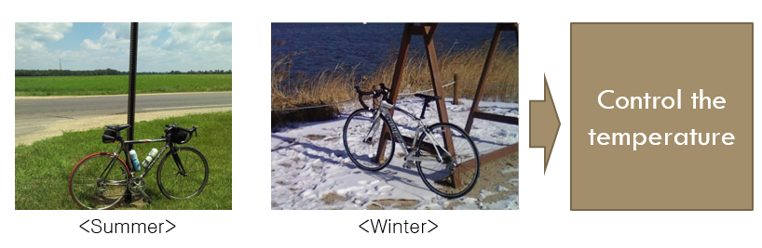

Figure 1: Motivation of the project

### *Patent Research*

There was similar project found below:

-Project: “Self-development by Hot/Cold Thermal bike” shown in Figure 2.

-Application number: 10-2012-0150282

-Content of patent: By using wheel’s rotation, generator makes the electricity. This electricity is used for working the peltier component. The peltier component generate heating on the handle and saddle.

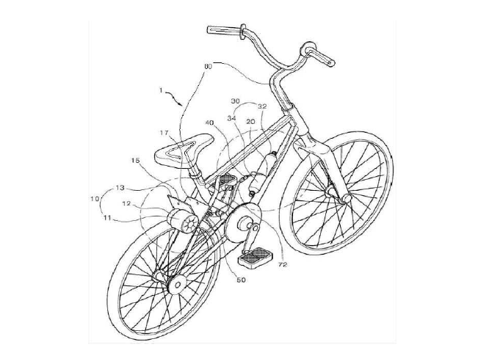

Figure 2: Self-development by Hot/Cold Thermal bike patent

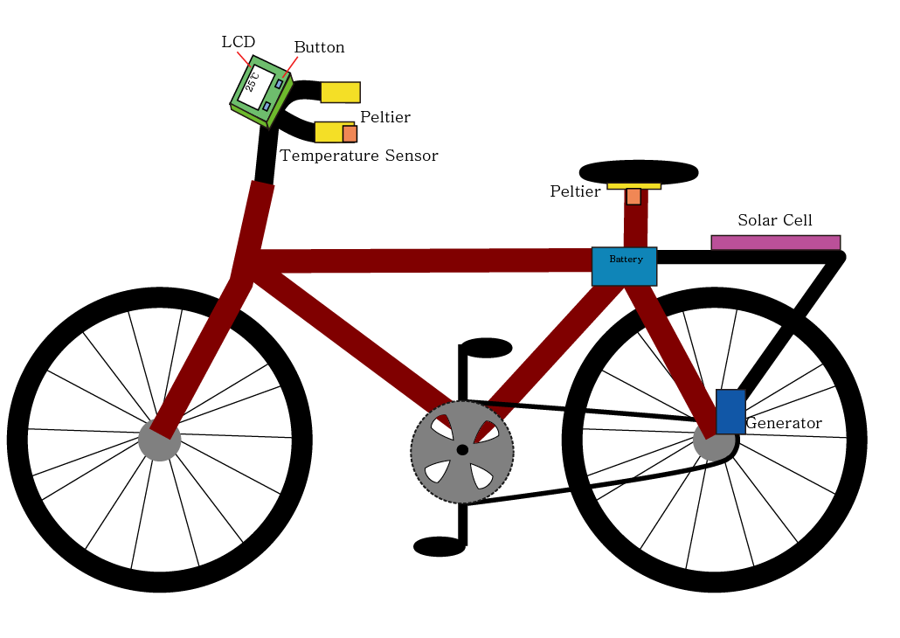

Figure 3: Design model

-What makes our design difference and improvements?

1. This patent just attaches the peltier component and they doesn’t have the embedded control system such as Arduino system. So the user can’t control the temperature of bicycle.

2. This patent doesn’t have the battery. This means that this system is working when bicycle’s wheel is rotating. Namely if the bicycle stops, then this system is not working.

### *Design model*

The generator and solar cell make the electricity which charged the battery. This battery’s role is power supply. By using the temperature sensor, we can read temperatures of handle and saddle. By using the Arduino we can control the peltier’s temperature. The design of the project is modeled in Figure 3.

## **Background**

### *Peltier effect*

In this part, we introduce the background knowledge which mainly deal with peltier effect. Concept of the project is “To make temperature difference using self-generator bicycle”. In detail, we have to generate the proper power for self-generating bicycle. And this power should make temperature difference from peltier module. For generating proper power, we use dynamo that is self-generator when we pedal the bicycle. For making temperature difference, we use peltier module (TEG module). Now, let’s focus on the reverse effect of peltier effect. At the atomic scale of peltier module, an applied temperature gradient causes charge carriers in the material to diffuse from the hot side to the cold side. Peltier module is an acronym for thermoelectric generator peltier modules and this is a type of sensor that produces power by using the temperature difference between upper boundary and lower boundary. We can call this progress as Seebeck effect. And reverse process is peltier effect we use in this project. Peltier effect can make temperature difference from voltage difference.

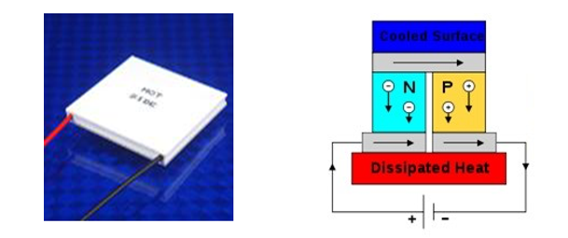

Figure 4: ‘module’(left) and process of generating temperature difference (right)

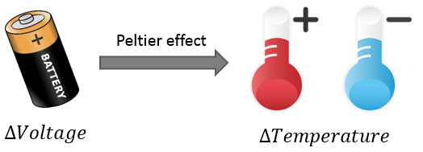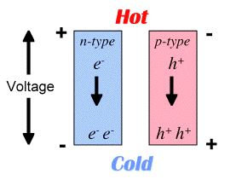

Figure 5: Principle of generating temperature difference

Let's look at mathematical details about the peltier effect. The temperature difference produced by Seebeck effect is the product of the voltage and electrical current across the load.

$$V=α∆T$$ Where: $$V=Voltage \\ α=Seebeck coefficient \\ ∆T=Temperature difference$$

In this formula, the temperature difference provides the voltage and then heat flow which enables the current. And we can change this formula to get temperature difference from the power.

$∆T= 〖〖1〗〗/〖〖α〗〗 V$

### *Nichrome wire*

In this part, we introduce the nichrome wire for heating solution. As we explained previous session, peltier module can make temperature difference from voltage. And it would have cold side and hot side at the same time. So we can use peltier module in our project. But we have to improve power efficiency, because team project is ‘Temperature controlling bicycle using self-generator’. When we search the data of peltier module, we found the peltier module has very low efficiency as approximately ~5%. So we will use nichrome wire have big resistivity for heating because we thought peltier module is not suitable module to make heating for bicycle. In contrast with peltier module, nichrome wire has high efficiency ~90%.

So we can reduce the cost for our project because nichrome wire is cheaper than Peltier module as well as higher efficiency.

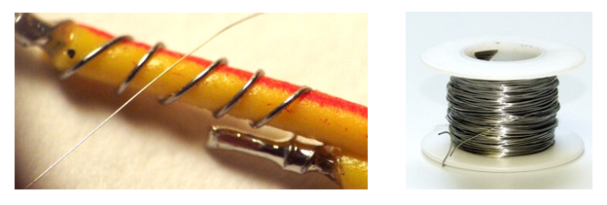

Figure 6: Nichrome wire for heating

And we can calculate the heat amount of nichrome wire from simple formula.

$$Heat amout=current^〖2 〗 ×resistance \\ resistance=resistivity × 〖〖length〗〗/〖〖area〗〗$$

From this formula, if we have same current, smaller area and longer length could make more heat.

### *Components*

Table 1: Components information

|  |  |
| --- | --- |
| **Components** | **Details** |
| 1. Cooling System | Peltier module x3 |
| 2. Heating System | Nichrome wire |
| 3. Temperature sensor | LM35 (-55° to +150°C) |
| 4. MCU | Arduino (54 digital I/O, 16 analog I/O,  4 UARTs, 16MHz crystal oscillator) |
| 5. Generator | Dynamo (Max output power : 4.09W) |
| 6. Battery | Li-ion Battery (7.4V 2600mAh) |
| 7. User interface | Button, LCD |

## **Electric Circuit**

This section deals with the electric circuit and circuit components that we will use.

### *Requirements*

As we are going to control the temperature of bicycle so we require both heating and cooling components. Since heating components will operate when environment temperature is very cold and user wants to increase the bicycle temperature. Cooling components will do its working when environment temperature is too hot and user wants to cool down the bicycle temperature.

We will use peltier material as heating component because it is semiconductor heat pump so it best suits our requirement but its efficiency is very low. Since peltier can also work as cooling component by just reversing the direction of current but due to its very low efficiency (about 5%) we will use nichrome wire as heating component.

To allow the user to interact with the temperature maintaining system it is natural to have a user interface. Our user interface will consist of a LCD and push buttons.

For the bicycle’s self-ability to generate enough power to keep running the system it’s important to use dynamo (generator) as power source. Since peltier use high power and requires high current for its proper operation we will not only use solar cell but also use electricity to keep the batteries charged. Hence rechargeable batteries are another requirement.

To control the whole system, we require a microprocessor. This microprocessor will take the user input and will make the output as per the instructions.

### *Selected Components as Required*

Since once we have made all of our requirements, now next step is to decide which component among its family would suit the best. Hence we have selected following components:

#### Peltier

Peltier has following properties:

* Thermoelectric materials
* Seebeck effect (converting temperature to current)
* Peltier effect (converting current to temperature)

We will use peltier material at three different locations: saddle, left side of handle, right side of handle

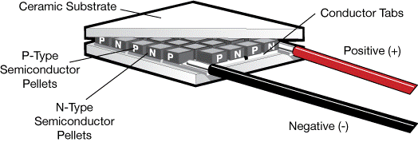

Figure 7: Illustration of peltier component

#### Heating Coil

Due to very low efficiency of peltier heating wire is optimal solution. We will use ni-chrome wire for heating purposes.

Figure 8: Nichrome wire

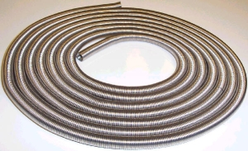

#### Power Amplifiers

Since peltier requires high power which microcontroller cannot provide so there is a need to amplify the power. There are many power amplifiers commercially available but they are expensive. So cost effective solution is to make your own power amplifier.

We will control peltier material and heating coil using PWM modulated signal.

Figure 9: Illustration of designed amplifier

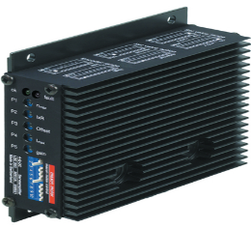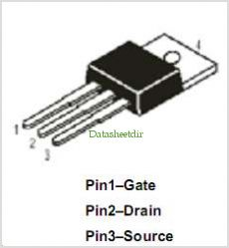

#### Arduino Microcontroller

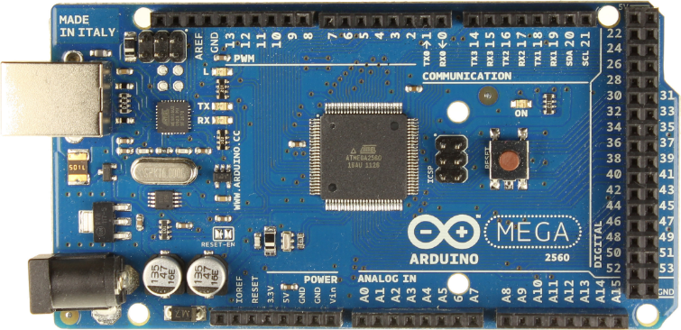Arduino microcontroller not only reads the user’s input via push buttons, displays output on LCD but also controls the bicycle temperature.

Figure 10: Arduino Mega2560

#### LCD

A 20x4 LCD we have decided to use for visual feedback to the user.

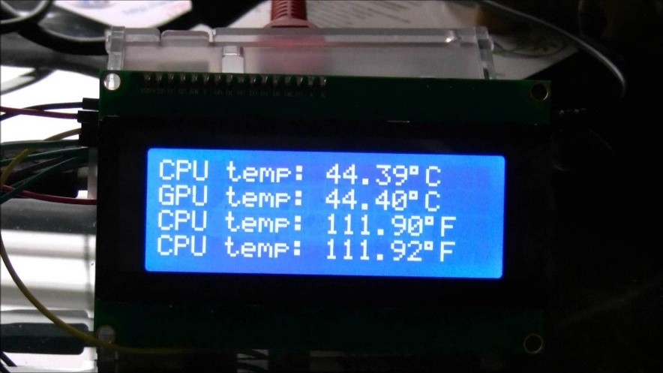

Figure 11: 20x4 LCD

#### Battery

High current portable rechargeable battery is the requirement to make the system work properly and efficiently.

Figure 12: Battery for the project

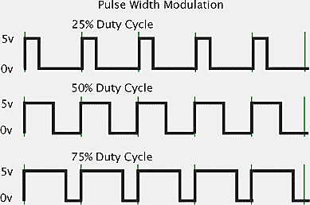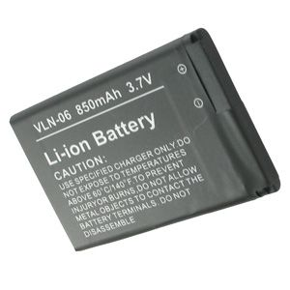

#### Solar Cell and Dynamo (Generator)

Renewable energy sources are the requirement for supplying enough power to the system. As we have decided so far, we will use two 6W solar cells and four 6W dynamos.

Figure 13: Solar cell and dynamo

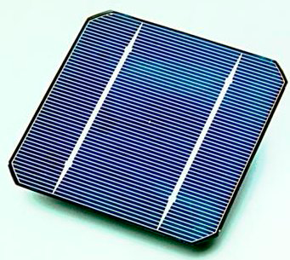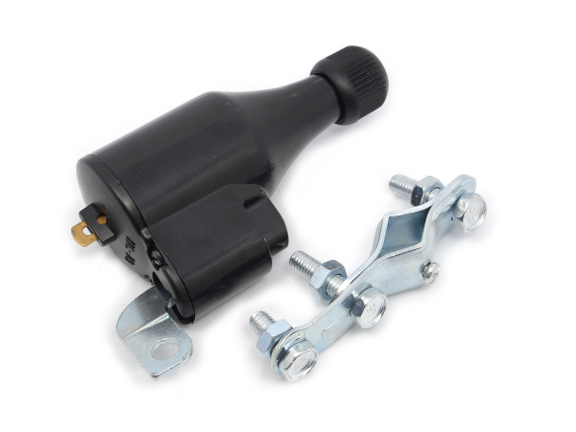

### *System flow diagram*

The following figure briefly describes the interaction of all devices with microcontroller.

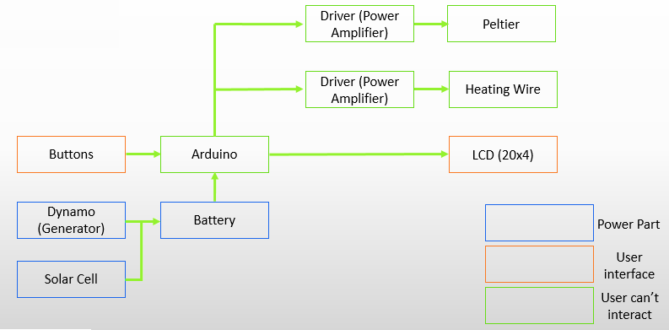

## **Software Design**

### *그림입니다. 원본 그림의 이름: CLP0000208c04b4.bmp 원본 그림의 크기: 가로 787pixel, 세로 440pixelHardware wiring*

Figure 14: Embedded Arduino circuit

This is the embedded Arduino circuit. As you can see from Figure 14, there are mainly 6 components: Arduino Mega, LM35 sensor, LCD, peltier component, driver, and a battery. All components are connected to Arduino Mega. LM35, a temperature sensor, is connected to 5V, GND (Ground), and A0 pin. A peltier driver, IRF, is connected to battery, peltier component and 5V (input) from Arduino Mega. Similarly, peltier component is also connected to battery and IRF (driver), except it is connected to GND from Arduino Mega. Various inputs from LCD are connected to Arduino Mega. LCD has total 16 inputs, and 1, 3, 5 are connected to GND. 2 is connected to VIN, 4 is connected to 30, 6 is connected to 31, 11 is connected to 32, 12 is connected to 33, 13 is connected to 34, and 14 is connected to 35. The rest is not connected to any components.

### *Algorithms*

The part presents the algorithms for embedded software programming for the bicycle temperature control projects. The main processing center unit is Arduino MCU communicating with several input/output peripherals with user interfaces. The global algorithm as illustrated in Figure 15a utilizes a *push_start* button which allows users to start controlling operations, when this button is pushed, the MCU initializes some variables which is shown in **“Initialization”** function, on other word pin connections between I/O peripherals and Arduino are defined. For example, three LM35 temperature sensors at three different positions; saddle position, left handle and right handle on the bike are pined to digital pin 0, 1, 2 on Arduino bound, respectively. Those initializations can be viewed as following (Figure 15b):

*const int sad_temp = 0; // saddle temp sensor*

*const int l_hand_temp = 1; // left handle temp sensor*

*const int r_hand_temp = 2; // right temp sensor*

Additionally, Initialization function defined the connection pins between MCU and LCD display as well as the peltier components. From the Initialization function, users found it easier to understand electronics circuitry and pin connections between components.

const int sad_temp = 0; // saddle temp sensor

const int l_hand_temp = 1; // left handle temp sensor

const int r_hand_temp = 2; // right temp sensor

const int push_start = 10; // power on

const int time_display = 11; // //display time

LiquidCrystal lcd(30, 31, 32, 33, 34, 35); //LiquidCrystal lcd(RS, E, D4, D5, D6, D7)

const int saddle_peltier=3;

const int left_handle_peltier=4;

const int right_handle_peltier=5;

Initialization

**Arduino power on**

**Void loop() {**

**}**

**Initialization**

**push_start = Vcc?**

**Y**

**N**

**Void setup() {**

**}**

Figure 15: Global algorithm and Initialization function

Figure 16

After we initialized the variable for pin connections, Arduino required the programmer to setup the baud rate which means data rate in bits per second for serial data transmission. LCD type is also setup in the part.

The primary algorithm for the project written in Loop function is visualized in Figure 16, in which the users are required to set lower bound and upper bound temperatures for what the bicycle start cooling and heating operations, respectively. Particularly, if the reading temperature is lowered than the setting lower bound one, Arduino will trigger cooling operation that cools the bike and comfort users. On the other hand, heating operation will be executed when the current temperature of the environment is read to be higher than the setup one.

The setting lower and higher bound temperature is followed by reading temperature from LM35 sensor starting with one located at the saddle and ending at one placed at right handle. Next, as explained the reading temperature will be conditionally checked with previously user-setup temp in order for Arduino to make the decision which operation it should perform or do nothing.

Figure 17: Loop function algorithm

Void loop

Set & Read temperature

sad_temp [T_loC T_hoC]

Saddle_pel_heating_operation

l_hand_pel_heating_operation

l_hand_pel_cooling_operation

**N**

**N**

**Y**

**Y**

**N**

l_hand_pel_stop_operation



Saddle_pel_stop_operation



Saddle_pel_cooling_operation

**Y**

l_hand_temp

> T_hoC

**Y**

**N**



**Y**

**N**

l_hand_pel_heating_operation

l_hand_pel_cooling_operation

**N**

**Y**

l_hand_temp

> T_hoC

l_hand_temp [T_loC T_hoC]

r_hand_temp [T_loC T_hoC]

LCD_display_operation

r_hand_pel_stop_operation

sad temp

> T_hoC

**Y**

**N**

time_display = Vcc?

time_display_operation

Delay(5000ms)



Then, the algorithm follows by calling the *LCD_display_operation* function. The fundamental purpose of the function is to display the reading temperatures.

The users have an option to see the current time if needed by pushing the *time_display* button which is one the user interface function. The button will call *time_display_operation* function.

### *Example code*

The example code for heating and cooling operation controlled by MCU Arduino are given as follows:

*analogWrite(saddle_peltier, 255); // saddle_peltier_heating_operation*

*analogWrite(saddle_peltier, -255); // saddle_peltier_cooling_operation*

*analogWrite(saddle_peltier, 0); // saddle_peltier_stopping_operation*

Saddle_peltier_heating_operation () {

analogWrite(saddle_peltier, 255);

}

Saddle_peltier_stopping_operation () {

analogWrite(saddle_peltier, 0);

}

Figure 18: Heating and cooling operation code example

# **Project portfolio**

## **Brainstorming idea**

In the first meeting, we fist decided the leader of our group 9, and Junho Song became the leader of our group since he was the one who suggested this idea. Then, we planned what we are going to do, and soon we realized that we need to decide which components we are going to order. We thought that we need time to search about components such as peltier component, solar cell, Arduino and so on. Thus, we decided to discuss about components in the next meeting.

In the 2nd meeting, we discussed about components, and also introduced good sites to order, and then we decided to set schedule for professor meeting. We also decided to order Arduino Mega as the MCU for our project.

In the third meeting, we discussed how we actually going to deliver heat to our bike. Abdullah suggested that we uses 3 to 4 peltier components for each handle and saddle, and each peltier component delivers heat or cold. However, some members such as Junho Song and Nguyen Thanh Duc explained that is not a good idea since it requires too many components. They suggested that they can use only one peltier component. After a long discussion, our group decided to use a nichrome wire for delivering heat because it delivers heat more efficiently than the peltier component does. Thus, we decided to use the peltier component for delivering cold. Also we decided our own role. For example, Jinho Song and Nguyen Thanh Duc took responsibility for software. After this meeting, our plan is going smoothly so far.

We finally come up with a final concrete design for our project after many brainstorming ideas. From that time on, we focus on realization the idea and make it become a product.

## **Project meeting**

* *September 9 2015*

It was the first meeting, we decided the leader of our group, discussed about the concept of our project and gave several brainstorming ideas.

* *September 15 2015*

In the second meeting, we continued brainstorming discussed about which components we need to order and introduced shopping mall sites to order, and then we talked about plan to get consulted with professor.

* *September 16 2015*

In the third meeting, we met Professor Hyo Sung Ahn and explained our brainstorming. We also met after dinner time and discussed about more detailed concept of our project.

* *September 18 2015*

In the fourth meeting, we met Professor Jae Hun Seol and discussed.

* *September late 2015*

In this meeting, we come up with a design and finalized components to order.

* *October 2 2015*

In the 6th meeting, we checked components we ordered and then we combined components and connected to Arduino Mega. Then, we decided individual responsibilities to the project.

* *October 8 2015*

In the 7th meeting, we connected peltier component to Arduino Mega, and also we tested code whether it actually works, and we improved and optimized the code. Then, we discussed about mid presentation.

* *October 14 2015*

In the 8th meeting, we discussed about mid presentation again and checked and reorganized our PPT file.

* *October 15 2015*

In the 9th meeting, we practiced oral presentation.

* *October 16 2015*

We had a mid-presentation.

* *October 27 2015*

In the 10th meeting, we discussed about mid-report starting fabrication on the bike.

* *October 30 2015*

In the 11th meeting, we will bring the actual bike and discuss how we place our components to the bike.

## **Project Timeline**

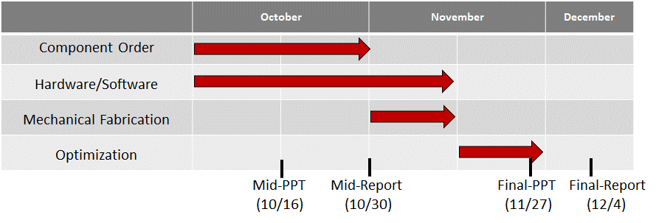

## **Future work**

Component order is already completed, although we are going order more components later. Our group is currently programming for Arduino. So far we connected Arduino to LCD, peltier component, and we are planning to connect to a generator and a solar cell. We are planning to finish everything by November 10th, and complete final-PPT.

## **Individual Responsibilities**

Junho Song is responsible for setting schedule and management and also hardware.

Abdullah Tahir and You Myung Ill are responsible for hardware and fabrication circuitry on the bicycle.

Nguyen Thanh Duc, Jinho Song and Abdullah Tahir are responsible for wiring components and software, which means programming.

However, our members also will help each other when we face troubles on work.

Table 2: Individual responsibility

|  |  |  |  |  |  |  |  |  |
| --- | --- | --- | --- | --- | --- | --- | --- | --- |
| Member/Task | Brainstorming + design model | Hardware | Component ordering | Fabrication | Software | Mid- presentation | Collecting reports | Leader  (Organize Schedule) |
| Abdullah Tahir | O | O |  | O | O |  |  |  |
| Junho Song | O | O | O | O |  |  |  | O |
| Jinho Song | O |  |  | O | O | O |  |  |
| Nguyen Thanh Duc | O |  |  | O | O | O | O |  |
| You Myung Ill | O | O | O | O |  |  | O |  |